**Business Data Processing With Pyton --Homework 3**

1)I do believe that the Holt Estimation technique gives the best results.

2) The smoothing approaches are seemed to be far better due to the changes in the RMSE and the graph shape changes. RMSE values get smaller and graphs turned out flatter with smoothening technique.

3) Due to the decreasing RMSE values, predictions are more accurate and better. So, I wouldn’t change window size of 60 minute of lags.

1-a-b

The RMSE Value of 15.57 is:

0.004942200138964736

The RMSE Value of 15.58 is:

0.0003087502531995412

1-c

RMSE Value of 15.57 is:

0.0310625847942001

RMSE Value of 15.58 is:

0.030242981238695066

2-ab

The RMSE Value for 15.57 is:

0.06862394732758403

The RMSE Value for 15.58 is:

0.06946060038947

2-c

5.950150942215886

5.950160497671341

0.06834905778411482

0.06916950232865915

3a

The estimation for 15:57 is:

6.0495625847942005

The estimation for 15:58 is:

6.049572981238695

The estimation for 16:00 7th of May is:

6.064564654199687

The estimation for 15:59 is:

6.049583377683189

The estimation for 16:00 is:

6.0495937741276835

The RMSE Value for 15.57 is:

0.0310625847942001

The RMSE Value for 15.58 is:

0.030242981238695066

3b

The estimation for 15:57 is:

6.0495625847942005

The stimation for 15:58 is:

6.049572981238695

The estimation for 16:00 for 7th of May is:

6.064564654199687

The estimation for 15:59 is:

6.049583377683189

The estimation for 16:00 is:

6.0495937741276835

The RMSE Value for 15.57 is:

0.0310625847942001

The RMSE Value for 15.58 is:

0.030242981238695066

3c

The estimation for 15:57 is:

6.023827327898611

The estimation for 15:58 is:

6.023827327898611

The estimation for 16:00 7th of May is:

6.034375881173967

The estimation for 15:59 is:

6.023827327898611

The estimation for 16:00 is:

6.023827327898611

RMSE Value of 15.57 is:

0.00532732789861079

RMSE Value of 15.58 is:

0.004497327898611125

#part1a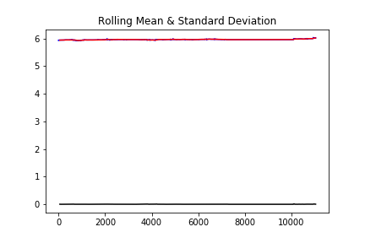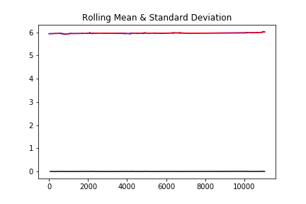

#part1-c

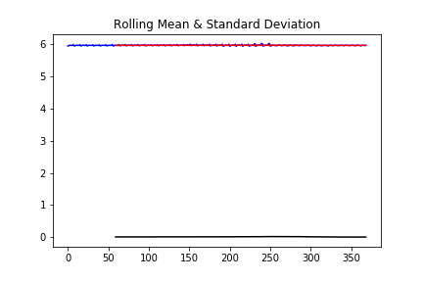

#part2a

#Part2c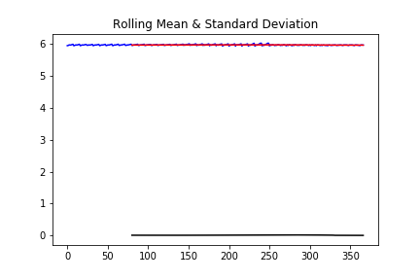

Part3a



